Topic: Fire retardant materials and surfaces
Self-stratifying fire retardant coatings
C. Lemesle^{1, 2}, A. Beaugendre¹, S. Bourbigot ¹, S. Duquesne¹, A.S. Schuller², M. Casetta¹, M. Jimenez ¹
¹ Université de Lille, Unité Matériaux et Transformations (UMET), UMR 8207, F-59000 Lille, France
² Mäder, 130 rue de la Mer Rouge, 68200 Mulhouse, France

Abstract:  The design of innovative coatings with multifunctional properties is very challenging. Self-stratification can be an alternative as it is an eco-efficient process allowing the formation, in only one application, of a multi-layer film gathering the following properties: adhesion to a substrate, a functional property such as flame retardancy and weathering protective properties and potentially many others. This effective and economical concept thus allows reducing the number of steps to coat a substrate, while providing a coating with equivalent or better performances than a common three layers process (primer-functional coating-topcoat), also reducing the amount of energy used, the pollution and waste generation¹.  For self-stratification to occur, liquid coatings must contain at least two partially incompatible thermosetting and thermoplastic polymers dissolved in a common solvent blend². In this work, an innovative self-stratifying coating based on epoxy (DGEBA)/silicone blend has been developed and applied on polycarbonate substrate. Perfect self-stratification was evidenced by microscopic analysis coupled with X-ray mappings³ (Figure 1). Flame retardant additives (2-10 wt.-%) were added to the formulation and the fire properties were evaluated via the determination of the Limiting Oxygen Index (LOI), UL94 and via Mass Loss Calorimetry (MLC). Some of the coatings allowed the formation of a protective barrier against fire and led to V0 rating at UL94 test and an increase of 28% to 35% in oxygen at LOI test. However, the increase in more stringent regulations on toxicological and environmental aspects now leads to the need of “green” flame retardant self-stratifying coatings. In this work, a “greener” self-stratifying coating with bio-based epoxy resin and specific solvent blend replacing xylene (Figure 2) will be presented and fully commented.  Keywords: Self-stratifying coating, fire retardant, epoxy/silicone blend, bio-based coating. | 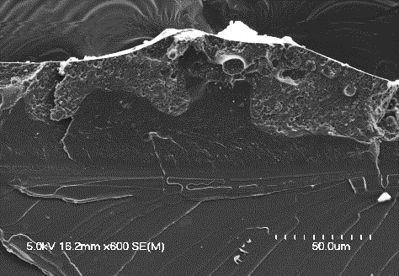  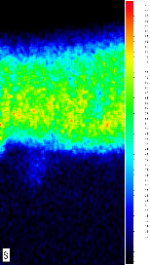  a)  Silicon  Substrate  Substrate  Epoxy  Silicone  b)  Figure 1: SEM micrograph of a cross section of a DGEBA/silicone based coating in butyl acetate : xylene (1:1); (a) self-stratified coating (b) EDS mapping of Silicon.  a)  b)  Substrate  Substrate  Epoxy  Silicone  Figure 2: SEM micrograph of a cross section of a bio-based epoxy/silicone based coating; (a) self-stratified coating (b) EDS mapping of Silicon.  References:  - A. Beaugendre et al. (2017), “Self-stratifying coatings: a review,” Prog. Org. Coatings, 110, pp. 210-241.  - A. Toussaint (1996), “Self-stratifying coatings for plastic substrates,” Prog. Org. Coatings, 28, pp. 183–195.  - A. Beaugendre et al. (2017), “Self-stratifying epoxy/silicone coatings,” Prog. Org. Coatings, 103, pp. 101–110.  Acknowledgements: French National Research Agency (ANR-14-CE27-0010), Matikem competitiveness cluster and Mäder company.

