Natural organic matter membrane fractionation of surface water – A new approach
Karlien Dejaeger^{a,b,c}, Justine Criquet^{b}, Marjolein Vanoppen^{a,d}, Cécile Vignal^{c}, Gabriel Billon^{b} and Emile R. Cornelissen^{a,d,e}
ª PaInT, Particle and Interfacial Technology group, Department of Green Chemistry and Technology, Faculty of Bioscience Engineering, Ghent University, Coupure Links 653, 9000 Ghent, Belgium
^{b} Univ. Lille, CNRS, UMR 8516 - LASIRE, Laboratoire Avancé de Spectroscopie pour les Interactions, la Réactivité et l’Environnement F-59000 Lille, France
^{c} Univ. Lille, Inserm, CHU Lille, U1286 - INFINITE - Institute for Translational Research in Inflammation, F-59000 Lille, France
^{d} Centre for Advanced Process Technology for Urban Resource Recovery (CAPTURE), www.capture-resources.be, Belgium

^{e} KWR Water Research Institute, Groningenhaven 7, 3433 PE Nieuwegein, Netherlands

Introduction
Natural organic matter (NOM), contained in drinking water resources, negatively affects drinking water quality by acting as nutrients for bacterial regrowth in the distribution system. Chlorine is a common disinfectant to inactivate pathogens, but it also reacts with NOM during disinfection to form disinfection by-products, which are correlated with health issues such as cancer. To identify the precursors that are responsible for the formation of these by-products from the complex NOM mixture, the latter is split into smaller fractions with similar chemical or physical properties. Dead-end ultrafiltration membrane fractionation is the most commonly used technique to split NOM by size, but is unable to produce sharply separated fractions. Therefore, this research will seek for a new membrane fractionation method that separate NOM into biopolymers, humic substances and low, molecular weight compounds. Subsequently, their reactivity towards chlorine and the formation of disinfection by-products will be determined.
Material and Methods
During fractionation, both a normal filtration step and a diafiltration step is executed. A model was constructed that predicts the concentration change for a certain compound during these two steps and was validated with a nanofiltration (Dow NF270). The model will be used to determine the time needed to have a good separation of the organic compounds for a certain water source.

$\ln{\frac{C_{f,t}}{C_{f,0}}}= -R*\ln\left(1-\frac{Q_{p}}{V_{0}}*t\right)$ (normal filtration)

$\ln{\frac{C_{f,t}}{C_{f,0}}}= \left(R-1\right)\frac{Q_{p}}{V_{0}}*t$ (diafiltration)
With C_{f} the concentration of the compound in the feed tank, R the retention, Q_{p} the flowrate and V₀ the initial feed volume.
Results and Conclusion
Figure 1 clearly shows that the model fits the experimental data very well during normal filtration mode (a,b). The fit during diafiltration is less accurate, but is rather explained by experimental variation (discontinuous adjustment of feed volume). The model will be equally validated with NOM concentrations and used to optimize membrane fractionation conditions.
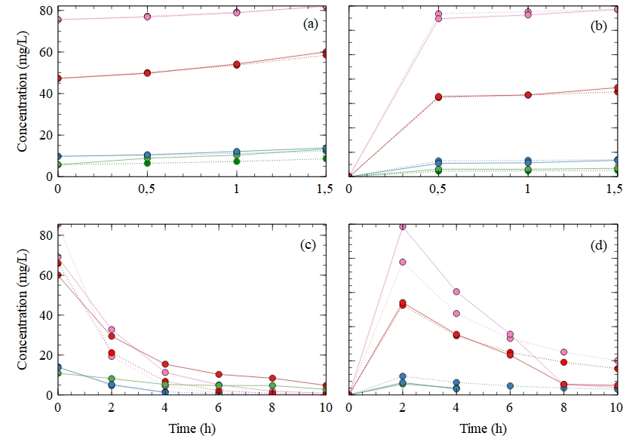
Figure 1: Ion concentrations in (a),(c) retentate and (b),(d) permeate during normal filtration ((a),(b)) and diafiltration ((c),(d)). Full lines represent experimental data, dotted lines predicted data of sodium (red), potassium (blue), magnesium (green) and chloride (pink).
Acknowledgements
This project has received funding from the European Union’s Horizon 2020 research and innovation program under the Marie Sklodowska-Curie grant agreement [No 847568].
The Region Hauts-de-France and the French government are warmly acknowledged through the founding of the CPERs Climibio and ECRIN. Professor Emile Cornelissen would like to acknowledge the FWO SBO-project Biostable [S006221N].

